________________________

Computer Science Project

Campus School Pantnagar

April 2018 - February 2019

___________________________________________

**Project Report**

on

**“Quiz in C++”**

**Submitted By**

Chitra Kandpal

Class: XII ‘A’

Roll No.: 14

**Submitted To**

Mr. M.D.Rawat

**Certificate**

This is to certify that this **Project Quiz** on the C++ language has been successfully developed by **Chitra Kandpal**, a student of class **XII ‘A’**, **Campus School Pantnagar** under the guidance of **Mr. M.D.Rawat** in particular fulfilment of the curriculum of Central Board of Secondary Education {CBSE} leading to the award of annual Computer Science Practical examination of the year **2018-19**.

**Mr. M.D.Rawat**

PGT (Computer Science)

Date: 22 January 2019

**Acknowledgement**

Primarily I would thank God for being able to complete this project with success. Then I would like to express my special thanks of gratitude to my computer science teacher Mr. M.D.Rawat whose valuable guidance has been the ones that helped me patch this project and make it full proof success his suggestions and his instructions has served as the major contributor towards the completion of the project.

Secondly, I would like to thank my parents and friends who helped me with their valuable suggestions and guidance has been helpful in various phases of the completion of the project.

Finally, I would like to thank my classmates who helped me a lot in finishing this project within the limited time.

**Chitra Kandpal**

Class XII ‘A’

Roll No. 14

Date: 22 January 2019

**Contents**

|  |  |
| --- | --- |
| **Certificate** | Page no. 1 |
| **Acknowledgements** | Page no. 2 |
| List of Contents | Page no. 3 |
| Overview of Project | Page no. 4 |
| Future work | Page no. 4 |
| List of Header Files included | Page no.5 |
| List of User Defined Functions | Page no. 5 |
| Binary Files Descriptions | Page no. 6 |
| **Source Code** | Page no. 6-15 |
| Screenshots of outputs | Page no. 16-21 |
| Bibliography | Page no. 22 |

**Overview of Project**

Quiz is a C++ application that has questions related to general Knowledge. It has multiple choice Questions and calculate scores of each correct/wrong answer. It helps in increasing general knowledge. Don't need register simply enter user name it will saved automatically and you can look in again with same user name in scorebook. Don't have to worry about the past score, it saves all record in binary files which can be access in future.

This application is developed to conduct a quiz. This Quiz system is accessed by entering the user name which is added to the binary file after you finish this quiz. Before start on the Quiz & player can see the rules and regulations using the “How to play” options in main menu, which will display the description for number of Questions and scoring methods. Quiz is started by displaying one Question with four options each based on General knowledge, if the answer is correct, score is incremented by 10pts and if wrong then negative 5pts is decremented from score. After 10 limited Random Questions, Quiz application will finally direct you to the score page where Final score will be displayed and updated in the binary file.

The main objective of Quiz Contest is to facilitate a user-friendly environment for all users and reduces the manual effort. In past days Quiz is conducted manually but in further resolution of the technology we are able to generate the score. The functional requirements include to create users that are point to participate in the Quiz & automatic score and report generation and administrative tasks like add questions & delete & clear scorebook for admin privilege users which requires pin to access.

**Future Work**

We have put an endless effort on this application and also provided room for future expansion of this application:

1.Interface can be enriched later.

2.Results with correct answers and Remarks can be display.

3.Levels as Easy, Medium and Hard may introduce.

4.References like links and book suggestions can be given to enrich the players knowledge.

**Header Files**

1. #include <conio.h>

For getch() , putch() and clrscr().

1. #include <stdlib.h>

For exit() , randomize() and random().

1. #include <stdio.h>

For gets() and remove().

1. #include <string.h>

For strcpy().

1. #include <fstream.h>

For cin , cout , fstream , read(), write() and close().

**User Defined Functions**

The list of user defined functions used in this application are as follows:

1. void setname(char nm[]); for setting players name
2. void scoreplus(); for incrementing players score if attempt is correct
3. void scoreminus(); for decrementing players score if attempt is wrong
4. char *getname(); returning players name
5. int getscore(); returning players score
6. void reset(); if player want to play again then clearing previous attempts
7. void quit(); if at any point user want to quit
8. void quiz(); function for taking quiz
9. void play(); Initializing the quiz by taking players name
10. void scoreboard(); for displaying the previous players score
11. void add_ques(); only admin can add questions
12. void del_ques(); deleting whole record file of questions only admin
13. void show_ques(); showing all record as questions only admin
14. void reset_score(); deleting whole record file of players only admin
15. void admin_panel(); menu to admin
16. void admin(); validating the admin pin i.e. 9897
17. void how_to_play(); printing how to play
18. void about_developer(); printing about development

**Binary Files Descriptions**

There are two binary files created and manage by this application:

1. “**question.dat**” – Questions are stored as structure records in this binary

file.

1. “**players.dat**” – Players records as class are stored in this players.dat

binary file.

**Source Code**

#include <conio.h>

#include <stdlib.h>

#include <stdio.h>

#include <string.h>

#include <fstream.h>

char ch;

class player{

private:

char name[50];

int score;

public:

void setname(char nm[]){

//for setting players name

strcpy(name,nm);

}

void scoreplus(){

//for incrementing players score if attempt is correct

score+=10;

}

void scoreminus(){

//for decrementing players score if attempt is wrong

score-=5;

}

char *getname(){//returning players name

return name;

}

int getscore(){//returning players score

return score;

}

void reset(){

//if player want to play again then clearing previous attempts

strcpy(name,"");

score=0;

}

}pl;

struct ques

{ char ques[200];

char opt1[100];

char opt2[100];

char opt3[100];

char opt4[100];

int ans;

};

void quit(){

//if at any point user want to quit

clrscr();

cout<<"Do you Really Want to Exit... ";

cout<<"Press 0 to exit otherwise any key..!\n";

ch=getch();

if(ch=='0'){

exit(0);

}

}

void quiz(){//function for taking quiz

ques qset[15];

int j,n=0,chk;

fstream file("question.dat",ios::binary|ios::in);

//input records as questions from binary file

while(file.read((char*)&qset[n],sizeof(qset[n]))){//fetching all records

n++;//no. of records fetch

}

randomize();

j=random(n);// for generating random questions

for(int i=1;i<=10&&i<=n;i++){

//display and ask for 10 questions answer

clrscr();

j=(j+1)%n;

cout<<"Question no."<<i<<" :"<<qset[j].ques<<"\n";

cout<<"\n\tOption 1: "<<qset[j].opt1<<"\n\t";

cout<<"Option 2: "<<qset[j].opt2<<"\n";

cout<<"\tOption 3: "<<qset[j].opt3<<"\n\t"

cout<<"Option 4: "<<qset[j].opt4<<"\n";

cout<<"\nEnter Right Option: ";

cin>>chk;

if(chk==qset[j].ans){

pl.scoreplus();

}

else{

pl.scoreminus();

}

}

clrscr();

fstream file1("players.dat",ios::binary|ios::app);

file1.write((char*)&pl,sizeof(pl));

file1.close();

cout<<"Thank You "<<pl.getname()<<" for playing and you Scored ";

cout<<pl.getscore()<<"pts\n";

cout<<"Press any key to jump to main menu\n";

getch();

}

void play(){

//Initializing the quiz by taking players name

clrscr();

cout<<"\n|||||||------------------- Quiz ----------------||||||\n";

cout<<"\n Enter Your Name :";

char n[50];

gets(n);

pl.setname(n);

cout<<"\nPress any key to start Quiz";

getch();

quiz();

}

void scoreboard(){

//for displaying the previous players score

clrscr();

fstream file1("players.dat",ios::binary|ios::in);

//fetching players record from players.dat binary file

player plyrs[20],temp;

int i=0;

while(file1.read((char*)&plyrs[i],sizeof(plyrs[i]))){

i++;

}

file1.close();

int flag=1;

while(flag){

flag=0;

for(int j=0;j<i-1;j++){

if(plyrs[j].getscore()<plyrs[j+1].getscore()){

temp=plyrs[j];

plyrs[j]=plyrs[j+1];

plyrs[j+1]=temp;

flag=1;

}

}

}

cout<<"|||||||||||------------ScoreBoard-----------||||||||||||\n\n";

cout<<"\tRanks\t\tName\t\t Score\n";

for(int j=0;j<i;j++){

cout<<"\t"<<j+1<<"\t\t"<<plyrs[j].getname()<<"\t\t\t";

cout<<plyrs[j].getscore()<<"\n";

}

cout<<"\n\n\nPress any key to jump to main menu..";

getch();

}

void add_ques(){

//only admin can add questions

fstream file("questions.dat",ios::binary|ios::app);

ques q;

do{

clrscr();

cout<<"\nEnter Question (max. characters 200 only): ";

gets(q.ques);

cout<<"\nEnter option 1 : ";

gets(q.opt1);

cout<<"\nEnter option 2 : ";

gets(q.opt2);

cout<<"\nEnter option 3 : ";

gets(q.opt3);

cout<<"\nEnter option 4 : ";

gets(q.opt4);

cout<<"\nEnter correct option no.:";

cin>>q.ans;

file.write((char*)&q,sizeof(q));

cout<<"\n\n Press Y to add one more question";

cout<<" otherwise any key:";

ch=getch();

}while(ch=='y'||ch=='Y');

file.close();

}

void del_ques(){//deleting whole record file of questions only admin

fstream file("question.dat",ios::binary|ios::in);

clrscr();

cout<<"Do you Really Want to delete all questions... ";

cout<<"Press 0 to continue otherwise any key..!\n";

ch=getch();

if(ch=='0'){

remove("question.dat");

}

file.close();

}

void show_ques(){//showing all record as questions only admin

fstream file("question.dat",ios::binary|ios::in);

ques q;

while(file.read((char*)&q,sizeof(q))){

clrscr();

cout<<"\nQuestion:"<<q.ques;

cout<<"\noption 1 : "<<q.opt1;

cout<<"\noption 2 : "<<q.opt2;

cout<<"\noption 3 : "<<q.opt3;

cout<<"\noption 4 : "<<q.opt4;

cout<<"\nCorrect option no.:"<<q.ans;

cout<<"\nPress any key to jump to next record";

getch();

}

file.close();

}

void reset_score(){//deleting whole record file of players only admin

fstream file1("players.dat",ios::binary|ios::in);

clrscr();

cout<<"Do you Really Want to clear all scores... ";

cout<<Press 0 to continue otherwise any key..!\n";

ch=getch();

if(ch=='0'){

remove("players.dat");

}

file1.close();}

void admin_panel(){

//menu to admin

clrscr();

int x=1;

do{

clrscr();

cout<<"||||||--------------------Admin----------------------|||||||\n";

cout<<"||||||--------------------Menu----------------------|||||||\n";

cout<<"\n";

cout<<"\t\t1.Show all Questions\n";

cout<<"\t\t2.Add Questions\n";

cout<<"\t\t3.Delete All Questions\n";

cout<<"\t\t4.Reset Scoreboard\n";

cout<<"\t\t5.Logout to main menu\n";

cout<<"\t\t6.Exit\n";

cout<<"\n\n\n\nNote*-Press the Serial no. ";

cout<<" to choose the option.\n";

ch=getch();

switch(ch){

case '1':

show_ques();

break;

case '2':

add_ques();

break;

case '3':

del_ques();

break;

case '4':

reset_score();

break;

case '5':

x=0;

break;

case '6':

quit();

break;

default:

cout<<"\nInvalid Option, press any key ";

cout<<"to Try again..!\n";

getch();

}

}while(x==1);

}

void admin(){

//validating the admin pin i.e. 9897

do{ ch='1';

clrscr();

char pin[5];

cout<<"\nEnter PIN:";

for(int i=0;i<4;i++){

pin[i]=getch();

putch('*');

}

pin[i]='\0';

clrscr();

if(strcmp(pin,"9897")==0){

admin_panel();

}

else{

cout<<"\nYou entered wrong pin,press 0 key ";

cout<<"to Try again otherwise any key to main menu";

ch=getch();

}

}while(ch=='0');

}

void how_to_play(){

//printing how to play

clrscr();

cout<<"\n|||||||-------------------How to Play----------------||||||\n";

cout<<"\nTHIS QUIZ CONSIST OF 10 QUESTIONS,\n";

cout<<"YOU WILL GET +10 FOR RIGHT RESPONSE \n";

cout<<"AND -5 FOR WRONG RESPONSE\n";

cout<<"TEST YOUR KNOWLEDGE\n";

cout<<"CHOOSE PLAY IN MAIN MENU TO START THE QUIZ";

cout<<"\n\n\n\nPress 0 to exit otherwise";

cout<<" any key to jump into main menu.\n";

ch=getch();

if(ch=='0'){

quit();

}

}

void about_developer(){

//printing about development

clrscr();

cout<<"\n|||||||-------------------About Development----------------||||||\n";

cout<<"\nTHIS QUIZ IS DEVELOPED FOR "

cout<<"THE PARTIAL FULFILLMENT \n";

cout<<"OF CBSE COMPUTER SCIENCE PROJECT ";

cout<<"CLASS 12TH A,\n";

cout<<"DURING FEBRUARY 2019,\nBY CHITRA KANDPAL, ";

cout<<" ROLL NO.14 .\n";

cout<<"\n\n\n\nPress 0 to exit otherwise any key";

cout<<" to jump into main menu.\n";

ch=getch();

if(ch=='0'){

quit();

}

}

void main(){//main menu ,, menu driven program

do{ clrscr();

pl.reset();

cout<<"||||||--------------------Quiz----------------------|||||||\n";

cout<<"||||||--------------------Menu----------------------|||||||\n";

cout<<"\n";

cout<<"\t\t1.Play\n";

cout<<"\t\t2.Scoreboard\n";

cout<<"\t\t3.Admin\n";

cout<<"\t\t4.How to play\n";

cout<<"\t\t5.About Development\n";

cout<<"\t\t6.Exit\n";

cout<<"\n\n\n\nNote*-Press the Serial no. ";

cout<<"to choose the option.\n";

ch=getch();

switch(ch){

case '1':

play();

break;

case '2':

scoreboard();

break;

case '3':

admin();

break;

case '4':

how_to_play();

break;

case '5':

about_developer();

break;

case '6':

quit();

break;

default:

cout<<"\nInvalid Option, press any key ";

cout<<"to Try again..!\n";

getch();

}

}while(1);

}

**Screenshots of outputs**

**Main Menu:**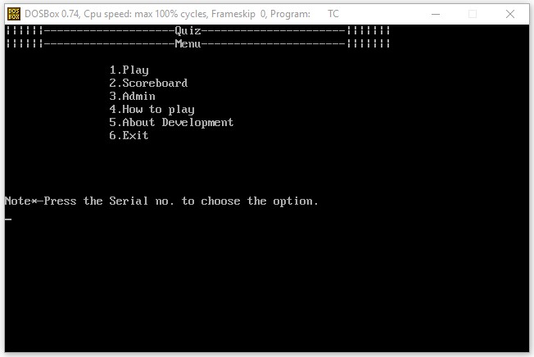

**Choose the option 4 How to play:** 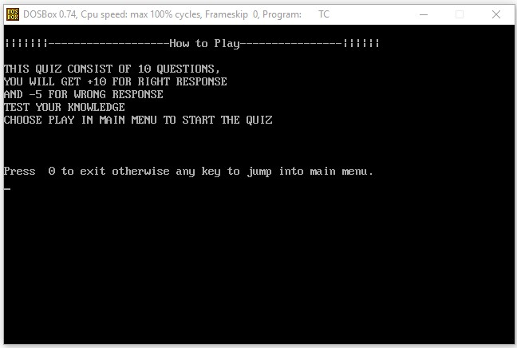

**Choose the option 5 About Development:** 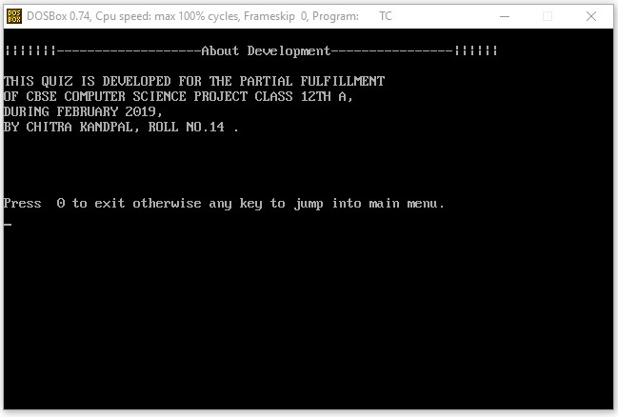

**Choose the option 1 Play: 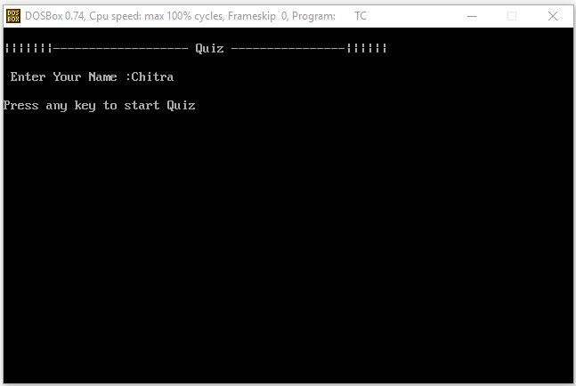After Entering Name and Pressing any key 1 Question at a time as:** 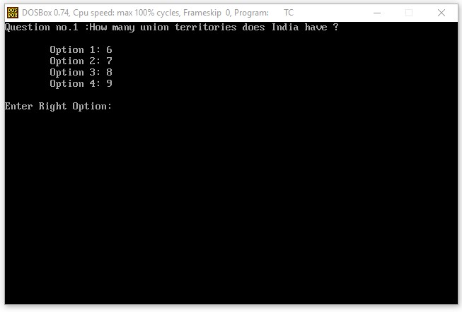

**After attempting all Question result displays as follows:** 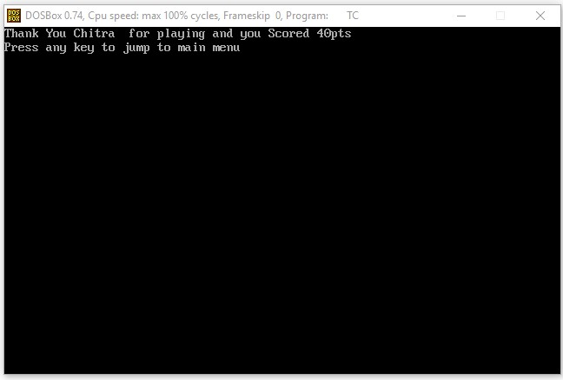

**Choose the option 2 ScoreBoard:**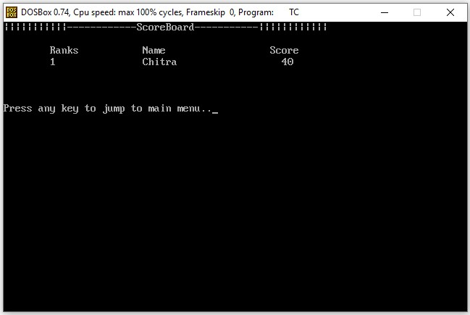

**Choose the option 3 Admin**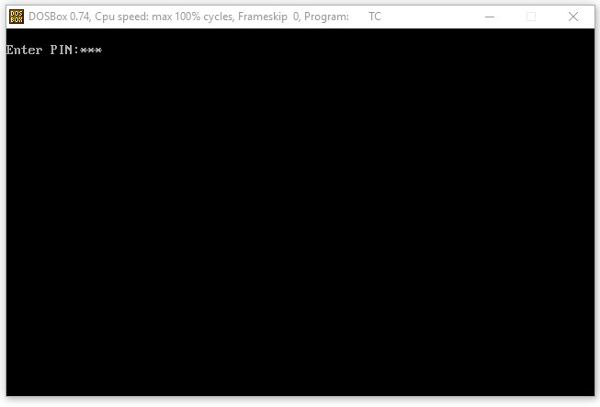

**After entering correct pin, admin control panel will open as follows:** 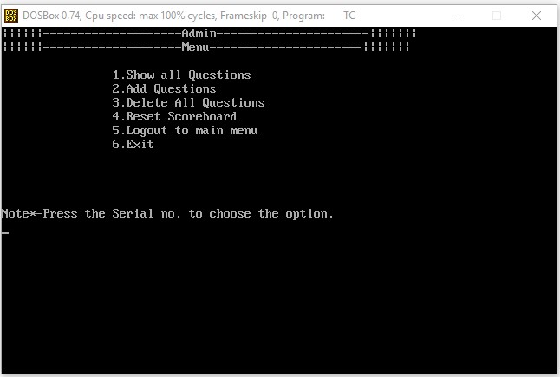

**Choose the option 1 Show all Question:** 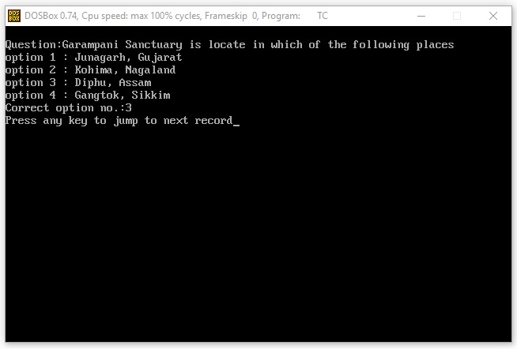

**Choose the option 2 Add Questions:**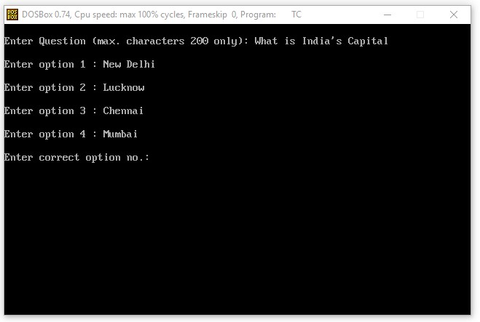

**Choose the option 6 Exit:**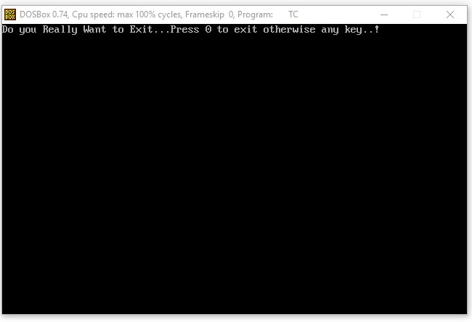

**Bibliography**

* https://en.wikipedia.org
* https://google.com
* Computer Science With C++ For Class XII Volume I & II

by Sumita Arora, Dhanpat Rai & Co.

* Computer Science With C++ For Class XI

by Sumita Arora, Dhanpat Rai & Co.

* Let Us C++

by Yashavant P. Kanetkar, BPB Publications